# 

**Enterprise Information System Assignment**

**Information System in Emirates Airlines**

**Module Title: Enterprise Information System (B9IS105)**

**Module Leader: Ms. Maria Barry**

**Student Name: Manik Mahashabde (10518579)**

**Prasad Rane(10520526)**

**Saurabh Devade(10531140)**

# Acknowledgment

We would like to express our sincere gratitude to our module leader Ms. Maria Barry for providing her invaluable guidance, comments, and suggestions throughout the entire project. We would also like to thank Mr. Trevor Haugh for giving a lecture on report writing and referencing.

Finally, we would like to thank Ms. Shazia Afzal for teaching us the concepts of Data Warehousing, Data Analytics, and Business Intelligence used in the project.

# Abstract

This project is the demonstration of an airline industry Emirates Airlines which uses various types of enterprise information systems to sustain its business model. EIS systems such as *Customer Relationship Management(CRM), Supply Chain Management(SCM), Management Information System(MIS), Transaction Processing System(TPS), Decision Support System(DSS), Executive Support System(ESS), Order Processing System(OPS)* are amongst the top information systems used in the Emirates Airline for sustainment of the business modal.

For better customer relations Emirates uses a variety of technologies such as sales force automation, customer service, and market automation. Apart from that, it includes various CRM options such as KIS (knowledge-driven inflight service) for tablet computers and loyalty programs for rewarding frequent flyers of the airline.

Supply Chain Management network of Emirates consists of teams responsible for providing aircraft, raw materials, and other essentials things required by following per under the specifications. Transaction Processing System consists of management of all the booking transaction data which emirates receive on their website or via a third-party website. Data collected at TPS in summarized into a series of reports used by the management team process done by the Management Information System team. Executive Support System is used by the senior management team to make strategic decisions. Decision Support System helps the management to make decisions in uncertain times. An *Order Processing System* is a class of information system which provide the information base for the day to day operation of the airline.

# Glossary

CRM: Customer Relationship Management is a strategy that companies use to manage interactions with customers and potential customers. CRM helps organizations streamline processes, build customer relationships, increase sales, improve customer service, and increase profitability. (Alshurideh, Alsharari, and Al Kurdi, 2019; Yang, 2010)

DSS: Decision-support system is used to help management make decisions in situations where there is uncertainty about the possible outcomes of those decisions. (*A decision support system for supplier selection in the airline industry - F T S Chan, H K Chan, R W L Ip, H C W Lau, 2007*, no date) (Chan et al., 2007)

EA: Emirates Airline

ESS: The Executive Support System is the type of information system which is used at the strategic level to help senior managers make strategic decisions. (Management information system in emirates airlines, tanveerrai, 2016)

**KIS**: Knowledge Driven Inflight Service is a software application that is a fully immersive crew and customer management solution that captures important passenger data around preferences and history. (Visser, Emirates Airline Serves Up New Inflight Experiences with Windows 8 - Microsoft 365 Blog, 2012)

MIS: A management information system is a computerized database of financial information organized and programmed in such a way that it produces regular reports on operations for every level of management in a company. (Management information system in emirates airlines, tanveerrai, 2016)

OPS: Order Processing System is a class of information system which provide the information base for the day to day orders. (Oleson et al)

SCM: Supply chain management is the process and activity of sourcing the raw materials or components an enterprise needs to create a product or service and deliver that product or service to customers. (Supply Chain Management In Emirates Airline Commerce Essay, 2016)

TPS: A Transaction Processing System is a set of information that processes the data transaction in the database system that monitors transaction programs. The system is useful when something is sold over the internet. (Transaction processing system - Computer Business Research, 2019)

# Table of Contents

Acknowledgment i

Abstract iii

Glossary iv

CRM iv

DSS iv

EA iv

ESS iv

MIS iv

OSS iv

SCM iv

TPS iv

Table of Contents v

TABLE OF FIGURES vi

LIST OF FIGURES vi

1. Introduction 1

1.1 Scope: 1

1.2 Background Information 1

2. Methodology 1

3. Findings 2

4. Discussions 2

4.1 Customer Relationship Management in Emirates: 3

4.2 Supply Chain Management of Emirates Airline: 3

4.3 Strategic Management of Emirates(MIS, DSS, ESS): 4

4.4 Transaction Management of Emirates: 5

5. Conclusions 5

6. Recommendations 6

BIBLIOGRAPHY 7

# TABLE OF FIGURES

Figure 1 - Research Methodology 2

Figure 2 - EIS used in Emirates Airlines 5

# LIST OF FIGURES

Table1 *-* FindingsTable 2

# 1. Introduction

The purpose of the report is to discuss the information system used in Emirates Airlines. Through this report, we want to address how Emirates has done the transformation of its business models using various enterprise information systems. How successfully Emirates reduced it’s IT costs, improved customer handling, provided better facilities and achieved it’s business goals.

## 1.1 Scope:

The scope of this report is limited to discussing efficient use of various information systems such as CRM, SCM, MIS, TPS, DSS, ESS in Emirates Airlines and how they all combine and make Emirates business model efficient.

## 1.2 Background Information

**Company Overview:** Emirates is the national Airline of Dubai in the Middle East region. Emirates flies to over 150 destinations in 80 countries across 6 continents and Emirates SkyCargo is responsible for the cargo activities. Emirates has existed for 35 years and currently, it is the fourth-largest airline by scheduled revenue passenger-kilometers flown. The key to its success is using new technology and information systems in the business process (‘Emirates (airline)’, 2020)

Emirates Airlines was founded in 1985. Throughout the entire period, Emirates has never reported a loss during its operation due to the business modal it follows. In early 2000 it started implementing CRM for better customer experience. As before CRM, Emirates had nothing to do with customers, only they come and go without any benefits. In 2004 Emirates also faced problems in the functioning of the aircraft the management team decided to restructure the complete procurement, operations and logistics aspects of the business.  (‘Emirates (airline)’, 2020)

# 2. Methodology

The research methods we used were independent research on the internet. We referred to a variety of websites such as Supply Chain Management of Emirates Airlines and Strategic Management of Emirates Airlines on the website ukessay.com, Management Information System on Emirates Airline on Slideshare, Case Study on CRM of Emirates on the website scrip.org

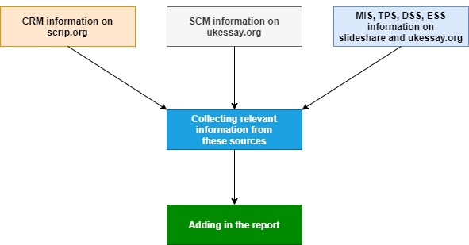

Figure - Research Methodology

We were in search of the information systems which are already implemented in Emirates. Hence we went through the number of websites and sorted and selected a few of them.

# 3. Findings

The Following were the important findings for the information systems of Emirates. These are adopted method in Emirates Airline

|  |  |
| --- | --- |
| CRM | It consists of three elements sales force automation, customer service, and marketing automation Use of Windows 8 KIS software technology and loyalty program CRM scheme. |
| SCM | Implementation of the Emirates Engineering group, Product Support Agreement group, and Direct Supplier group. |
| DSS | It helps the management team to make decisions in case of uncertainty. Compensation Analysis System is used as DSS in Emirates. |
| ESS | Senior managers making strategic decisions. For example, adding new destinations or purchasing a new airplane. |
| KIS | This system involves the identification of a new market for the business. Competitive Intelligent System of the Emirates uses KIS. |
| MIS | Analyzing data from transactions and making a report. Budget System and Pricing Analysis System of the Emirates uses MIS. |
| TPS and OPS | Emirates uses it to keep track of daily orders and transactions. |

*Table 1 - Findings Table*

# 4. Discussions

Let us now discuss how Emirates has implemented various types of Information Systems to sustain its business model.

## 4.1 Customer Relationship Management in Emirates:

The CRM system of Emirates consists of three elements: sales force automation, customer service, and marketing automation. CRM has integrated four important aspects of customer relations: Cooperation, Communication, Coordination, and Collaboration from all organizational employees. Emirates was also the first company in the middle east to use CRM software KIS( Knowledge-driven In-flight Service) (Alshurideh, Alsharari, and Al Kurdi, 2019; Yang, 2010)

Mainly there are two different types of CRM to attract customers:

**Windows 8 CRM**: Before this cabin crew officer, used to record flight notes with pen and paper. Then Emirates Airlines created its business application, KIS which allows pursers to use laptops to take stock of what transpired on a flight and how better serve the passengers. Emirates used a specific CRM database, which runs during the flight to maintain a profitable long-term relationship with their customers by delivering satisfaction. It introduced in-flight Windows 8 tablets that enable cabin crew to access core CRM and HR information to improve customers’ services. (Visser, Emirates Airline Serves Up New Inflight Experiences with Windows 8 - Microsoft 365 Blog, 2012)

KIS allows the airline’s cabin crew to understand which previous trips a passenger has taken with Emirates and based on this, knows their cuisine, drink, and seating preferences, or any problems a customer had during their travels. Team use KIS to brief the cabin crew before every flight and check each passenger’s special needs, as well as check who is enrolled in Emirates’ frequent flyer program Skywards. This enables the cabin crew to invest more in those old and loyal customers and to provide more personalized service.

**Loyalty Program Based CRM**: A loyalty program was implemented to satisfy customers which allowed them to save money and gathering personal information about those clients. It also created a lock-in system where a specific customer should remain with the same airline to get discount benefits. It offers membership in two types of loyalty programs: Emirates Skywards and Business Rewards. (Alshurideh, Alsharari, and Al Kurdi, 2019; Yang, 2010)

Emirates Skywards was the award-winning frequent flyer program which was launched in May 2000 (Alshurideh, Alsharari, and Al Kurdi, 2019; Yang, 2010). Membership to this program provided access to many special benefits designed to make travel more rewarding and enjoyable for the customers.

Business Rewards is another such loyalty program of Emirates, which is open to small and medium-sized enterprises (SMEs) around the world. Organizations earn Business Rewards Miles on flights taken by their employees, which can be spent in the form of Rewards flights and upgrades.

## 4.2 Supply Chain Management of Emirates Airline:

When Emirates faced problems in the functioning of its aircraft in 2004, at that time the management team decided to restructure the complete procurement, operations and logistics aspects of the business. The Procurement section in the Emirates handles all contracting and outsourcing contracts of aircraft that comprise of fleet, equipment, spares, power plants, catering services, and many more things. The entire team implemented a precise process approach by working together as a cross-functional team; in these teams, the experts of all divisions were included to ensure that the supply chain requirements of the business are met at the required level. (Supply Chain Management In Emirates Airline Commerce Essay, 2016)

The present Supply Chain network of Emirates Airline can be divided primarily into three main categories that are interlinked:

1. Emirates Engineering provides top quality aircraft and facilities to the Emirates Group so that it can meet the requirements of its customers.
2. Product Support Agreements (PSAs) are signed between the two groups which are the Procurement Department and supplier of the division who ensures that the airline is provided aircraft by following per under the specifications.
3. Then the suppliers have agreements with their suppliers named ‘direct suppliers’ who ensure that the finest raw materials are provided for manufacturing the fleet with measurements set by Emirates.

## 4.3 Strategic Management of Emirates(MIS, DSS, ESS):

In Emirates there are four managerial levels involved similar to any typical Management Information Systems which are responsible for the proper functioning of an organization, In Emirates, these levels are Decision, Strategic, Tactical, knowledge, and operations levels.

**Strategic Decisions:** These decisions are generally considered as the least structured but they can have a significant impact on the future of an organization, e.g adding new destinations to Emirates’ existing flight schedules. The *Executive support system (ESS)* is such a type of information system that is used at a strategic level to help senior managers in making strategic decisions. This type of decision involves adding new destinations in the existing flight schedules or buying a new aircraft. (Management information system in emirates airlines, tanveerrai, 2016)

**Tactical Decisions:** Decisions in tactical level support strategic decisions, they are generally medium-range decisions and taken by middle-level managers. In Emirates, the important decision to increase the profit per year is supported by taking tactical decisions. These decisions are made based on the data from sales orders. *Management Information Systems(MIS)* and *Decision-Support Systems(DSS)* are two significant systems that help the team in making tactical decisions. (*A decision support system for supplier selection in the airline industry - F T S Chan, H K Chan, R W L Ip, H C W Lau, 2007*, no date) (Chan et al., 2007)

Management Information Systems mainly focuses on internal information and generally takes data from Transaction Processing Systems and by summarizing it into a series of management reports. Budgeting System of Emirates which is used for preparing short term budgets is an example of this system used by middle managers. Pricing Analysis System is another such system that is used for determining ticket prices and promotions.

*Decision-support System (DSS)* helps management make decisions in difficult situations where there is uncertainty about the possible outcomes of those decisions. Compensation Analysis System is a DSS that provides an overview of the organization’s expenditure, salaries, monitors wages, and benefits for the manager.

**Knowledge Decisions:** These decisions are generally made by designers and engineers. This decision involves the identification or acknowledgment of a new business market for the airline. Knowledge Management Systems are generally used at this level of decision making. Competitive Intelligent System works on a business model which helps in identifying what kind of information to collect. Another example of this kind is the Market Analysis System that provides technical analysis tools for analysis of the financial market. (Visser, Emirates Airline Serves Up New Inflight Experiences with Windows 8 - Microsoft 365 Blog, 2012)

**Operation Decisions:** These are used to support tactical decisions. At the operational level, the daily requirement is reviewed by the team based on which the team takes the decision. In this kind of system, the information about lights, passengers, crew, situational, and environment are gathered.

## 4.4 Transaction Management of Emirates:

TCS is one of the current systems in Emirates that is used to support the transaction and analytical processing of newly received operational information. Order Processing System is another such system that keeps track of daily transactions and orders. (Transaction processing system - Computer Business Research, 2019)

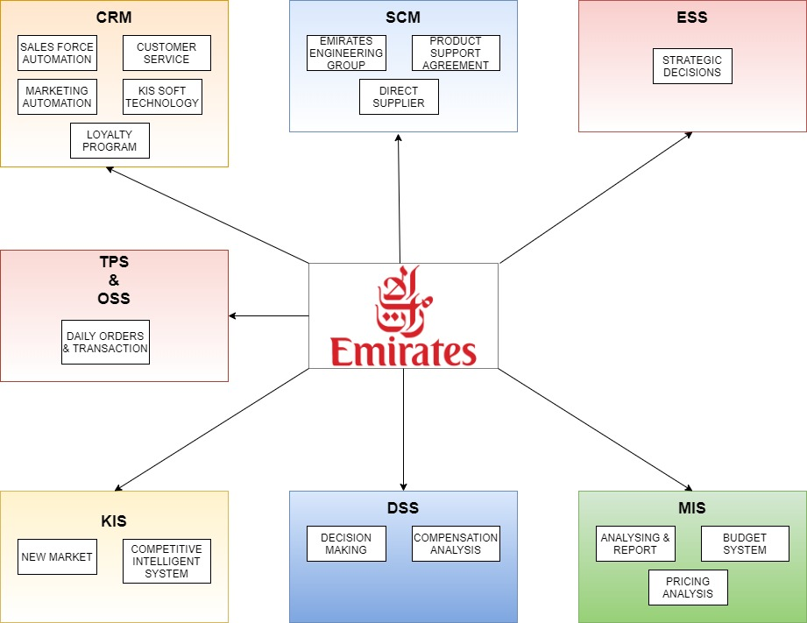

Figure 2 - EIS used in Emirates Airlines

# 5. Conclusions

To conclude with we observed the following things with regards to Enterprise Information Systems used in Emirates.

Overall we can say that due to the usage of CRM, SCM, MIS, TPS, DSS, ESS and KIS. The Emirates has done exceptionally well in the East-Asia region. Emirates implemented CRM in 2000 as before this it had nothing to do with the customer. But, since the implementation of CRM Emirates has seen to be successful in maintaining a good relationship with customers, small and medium-size business industries due to their various CRM schemes such as Windows 8 KIS and the loyalty program scheme. In terms of SCM, they introduced it in 2004 while facing problems in the functioning of the aircraft. They had to restructure the SCM by introducing Emirates Engineering group, Product Support Agreement group, and Direct Supplier group.

The Strategic management team of the Emirates is responsible for making strategic, tactical, knowledge and operation decisions. Decisions such as managing the organization in uncertain times, buying new aircraft, expanding the market, etc. are taken under this domain. TPS which keeps records of order and transactions helps the MIS team to make reports.

# 6. Recommendations

Although the current information system of Emirates in highly functional and efficient. All seven information systems have helped Emirates to take up a spot of most reputed and luxuries airline in East-Asia. But, since the time is changing and the technologies are becoming more advanced. It also results in lots of new kinds of challenges such as security threats, rapidly changing business scenario due to Globalization.

As per our suggestion, we would recommend Emirates include Artificial Intelligence technology in their existing information system. They can implement an **AI for the identification of passengers** at airports which will make passenger identification fast for officials as well. *Delta Airlines* uses this technology in the United States. They can also implement **AI in the Transaction Processing Information System** for more security. The Emirates can also use **AI for customer handling** which will result in the reduction of operational cost and labor cost. It will also help in solving issues quickly. AI can also be used in the **maintenance of aircraft** to determine when it is the right for maintenance depending upon the condition of aircraft. **Air-Traffic Management using AI**, **baggage screening using AI**. Efficient implementation of these new technologies will surely help Emirates to reach new heights. (Emirates says working on AI-powered flight ‘assistant’ - Arabianbusiness, 2019; What can Artificial Intelligence do for the Aviation industry | Packt Hub, 2019; Marr, The Amazing Ways Dubai Airport Uses Artificial Intelligence, 2019)

# BIBLIOGRAPHY

Alshurideh, M., Alsharari, N.M. and Al Kurdi, B. (2019). Supply Chain Integration and Customer Relationship Management in the Airline Logistics. Theoretical Economics Letters, 09(02), pp.392–414.

ArabianBusiness.com. (2019). Emirates says working on AI-powered flight “assistant.” [online] Available at: <https://www.arabianbusiness.com/travel-hospitality/419594-emirates-says-working-on-ai-powered-flight-assistant> [Accessed 25 Mar. 2020].

Chan, F.T.S., Chan, H.K., Ip, R.W.L. and Lau, H.C.W. (2007). A decision support system for supplier selection in the airline industry. Proceedings of the Institution of Mechanical Engineers, Part B: Journal of Engineering Manufacture, 221(4), pp.741–758.

EMIRATES (n.d.). About us | Emirates. [online] Global. Available at: <https://www.emirates.com/english/about-us/?article=819068&offset=0>.

Marr, B. (2019). The Amazing Ways Dubai Airport Uses Artificial Intelligence. [online] Forbes. Available at: <https://www.forbes.com/sites/bernardmarr/2019/07/26/the-amazing-ways-dubai-airport-uses-artificial-intelligence/#20937ab52a21> [Accessed 25 Mar. 2020].

Oleson, V., Schwan, K., Eisenhaur, G., Plale, B., Pu, C. and Amin, D. (n.d.). Operational Information Systems -An Example from the Airline Industry. [online] Available at: <https://www.usenix.org/legacy/events/wiess2000/full_papers/oleson/oleson.pdf> [Accessed 25 Mar. 2020].

Packtpub.com (2019). What can Artificial Intelligence do for the Aviation industry | Packt Hub. [online] Packt Hub. Available at: <https://hub.packtpub.com/what-can-artificial-intelligence-do-for-the-aviation-industry/>.

tanveerrai (2016). Management information system in emirates airlines. [online] Slideshare. Available at: <https://www.slideshare.net/tanveerrai/management-information-system-in-emirates-airlines> [Accessed 25 Mar. 2020].

Transaction processing system - Computer Business Research (2019). Transaction processing system - Computer Business Research. [online] Computerbusinessresearch.com. Available at: <http://www.computerbusinessresearch.com/Home/decision-making/transaction-processing-system>.

UKESSAYS (2016). Supply Chain Management In Emirates Airline Commerce Essay. [online] UKEssays.com. Available at: <https://www.ukessays.com/essays/commerce/supply-chain-management-in-emirates-airline-commerce-essay.php> [Accessed 25 Mar. 2020].

Visser, E. (2012). Emirates Airline Serves Up New Inflight Experiences with Windows 8. [online] Microsoft 365 Blog. Available at: <https://www.microsoft.com/en-us/microsoft-365/blog/2012/11/19/emirates-airline-serves-up-new-inflight-experiences-with-windows-8/> [Accessed 25 Mar. 2020].

Yang, N. (2010). Research on the customer relationship management of real estate enterprise. [online] IEEE Xplore. Available at: <https://ieeexplore.ieee.org/stamp/stamp.jsp?tp=&arnumber=5607408> [Accessed 25 Mar. 2020].

‌